**DAILY ONLINE ACTIVITIES SUMMARY**

|  |  |  |  |  |  |  |  |  |
| --- | --- | --- | --- | --- | --- | --- | --- | --- |
| **Date:** | **13/06/2020** | | | | | **Name:** | **Manish B Shriyan** | |
| **Sem & Sec** | **8th sem B sec** | | | | | **USN:** | **4AL16CS131** | |
| **Online Test Summary** | | | | | | | | |
| **Subject** | | **IOT** | | | | | | |
| **Max. Marks** | | **30** | | **Score** | | | **29** | |
| **Certification Course Summary** | | | | | | | | |
| **Course** | **Python the first level** | | | | | | | |
| **Certificate Provider** | | | **AWS** | | **Duration** | | | **3 Hours** |
| **Coding Challenges** | | | | | | | | |
| **Problem Statement:**  **Python program to find N largest elements from a list** | | | | | | | | |
| **Status: Solved** | | | | | | | | |
| **Uploaded the report in Github** | | | | | **Uploaded** | | | |
| **If yes Repository name** | | | | | **ManishShriyan** | | | |
| **Uploaded the report in slack** | | | | | **Yes** | | | |

Online Test Details:

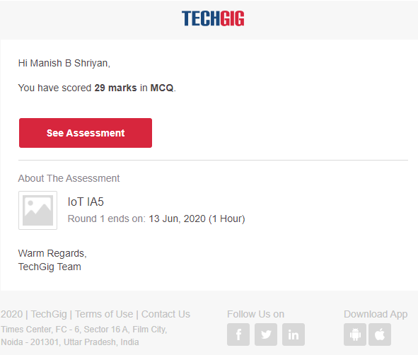

Certification Course Details:

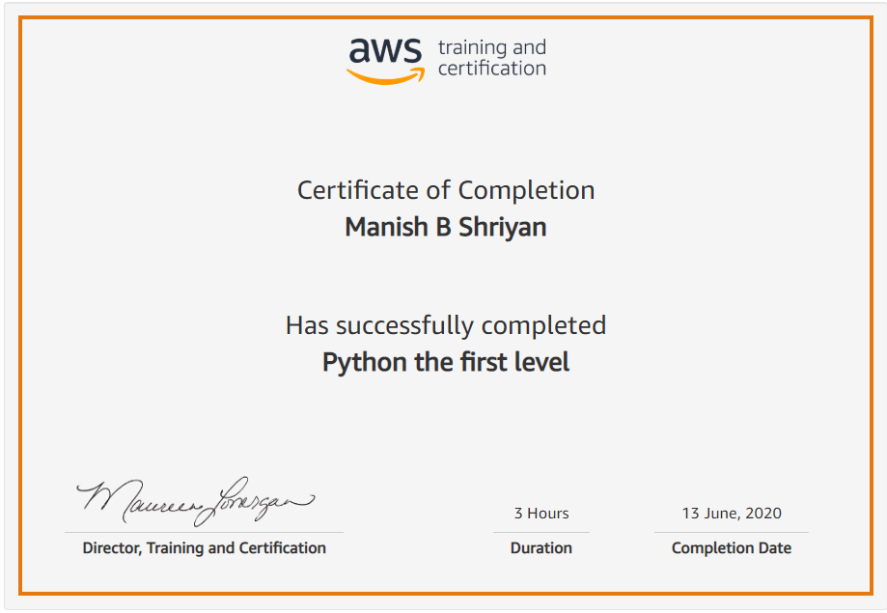

Coding Challenges Details:

|  |
| --- |
|  |
|  |  |
|  |  |
|  |  |
|  |  |
|  |  |
|  |  |
|  |  |
|  |  |
|  |  |
|  |  |

**# Python program to find N largest**

**# element from given list of integers**

**# Function returns N largest elements**

**def Nmaxelements(list1, N):**

**final_list = []**

**for i in range(0, N):**

**max1 = 0**

**for j in range(len(list1)):**

**if list1[j] > max1:**

**max1 = list1[j];**

**list1.remove(max1);**

**final_list.append(max1)**

**print(final_list)**

**# Driver code**

**list1 = [2, 6, 41, 85, 0, 3, 7, 6, 10]**

**N = 2**

**# Calling the function**

**Nmaxelements(list1, N)**